Day 3 - API Integration and Data Migration

Objective
The goal was to integrate APIs into a Next.js project, set up Sanity CMS, and migrate data into Sanity CMS to create a functional marketplace backend. This task involved installing necessary tools, configuring the environment, writing schemas, and migrating data using scripts.

Steps Followed

1. Installing Next.js and Sanity CMS
- Initialized a new Next.js project.
- Installed Sanity CMS and selected the eCommerce template during setup.
- Configured the project ID and dataset in the setup process.

2. Setting Up Environment Variables
- Created a .env.local file to securely store environment variables, such as the Sanity project ID, dataset name, and API token.
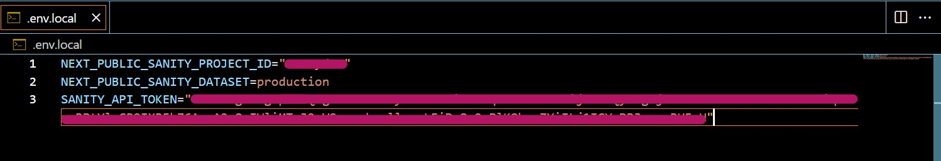

3. Writing Sanity Schema
- Defined schemas for products and categories in the project.
- Ensured that the fields matched the data structure from the API.

import { defineType } from "sanity"

export default defineType({
name: 'products',
title: 'Products',
type: 'document',
fields: [
{
name: 'name',
title: 'Name',
type: 'string',
},
{
name: 'price',
title: 'Price',
type: 'number',
},
{
name: 'description',
title: 'Description',
type: 'text',
},
{
name: 'image',
title: 'Image',
type: 'image',
},
{
name:"category",
title:"Category",
type: 'string',
options:{
list:[
{title: 'T-Shirt', value: 'tshirt'},
{title: 'Short', value: 'short'},
{title: 'Jeans', value: 'jeans'} ,
{title: 'Hoddie', value: 'hoodie'} ,
{title: 'Shirt', value: 'shirt'} ,
]
}
},
{
name:"discountPercent",
title:"Discount Percent",
type: 'number',
},
{
name:"new",
type: 'boolean',
title:"New",
},
{
name:"colors",
title:"Colors",
type: 'array',
of:[
{type: 'string'}
]
},
{
name:"sizes",
title:"Sizes",
type: 'array',
of:[
{type: 'string'}
]
}
],
})

4. Writing the Migration Script
- Wrote a script to fetch data from the provided API and migrate it into Sanity CMS.
- Mapped API fields to schema fields and handled data transformation where needed.
- import { createClient } from '@sanity/client';
- import axios from 'axios';
- import dotenv from 'dotenv';
- import { fileURLToPath } from 'url';
- import path from 'path';

- // Load environment variables from .env.local
- const __filename = fileURLToPath(import.meta.url);
- const __dirname = path.dirname(__filename);
- dotenv.config({ path: path.resolve(__dirname, '../.env.local') });

- // Create Sanity client
- const client = createClient({
- projectId: process.env.NEXT_PUBLIC_SANITY_PROJECT_ID,
- dataset: process.env.NEXT_PUBLIC_SANITY_DATASET,
- useCdn: false,
- token: process.env.SANITY_API_TOKEN,
- apiVersion: '2021-08-31',
- });

- // Function to upload an image to Sanity
- async function uploadImageToSanity(imageUrl) {
- try {
- console.log(`Uploading image: ${imageUrl}`);

- // Validate the image URL
- if (!imageUrl || typeof imageUrl !== 'string') {
- console.error('Invalid image URL:', imageUrl);
- return null;
- }

- // Fetch the image as a buffer
- const response = await axios.get(imageUrl, { responseType: 'arraybuffer' });
- const buffer = Buffer.from(response.data);

- // Upload the image to Sanity
- const asset = await client.assets.upload('image', buffer, {
- filename: imageUrl.split('/').pop(),
- });

- console.log(`Image uploaded successfully: ${asset._id}`);
- return asset._id;
- } catch (error) {
- console.error('Failed to upload image:', imageUrl, error.message || error);
- return null;
- }
- }

- // Function to import data
- async function importData() {
- try {
- console.log('Fetching products from API...');
- const response = await axios.get('https://template1-neon-nu.vercel.app/api/products');
- const products = response.data;

- if (!Array.isArray(products)) {
- throw new Error('Invalid data format: Expected an array of products');
- }

- console.log(`Fetched ${products.length} products`);

- for (const product of products) {
- console.log(`Processing product: ${product.name}`);

- let imageRef = null;
- if (product.imageUrl) { // If image URL is provided
- console.log(`Uploading image for product: ${product.name}`);
- imageRef = await uploadImageToSanity(product.imageUrl);

- if (!imageRef) {
- console.warn(`Failed to upload image for product: ${product.name}`);
- }
- }

- const sanityProduct = {
- _type: 'products',
- name: product.name,
- price: product.price,
- description: product.description,
- image: imageRef
- ? {
- _type: 'image',
- asset: {
- _type: 'reference',
- _ref: imageRef,
- },
- }
- : undefined,
- category: product.category,
- discountPercent: product.discountPercent || 0,
- new: product.isNew || false,
- colors: product.colors || [],
- sizes: product.sizes || [],
- };

- console.log('Uploading product to Sanity:', sanityProduct.name);
- const result = await client.create(sanityProduct);
- console.log(`Product uploaded successfully: ${result._id}`);
- }

- console.log('Data import completed successfully!');
- } catch (error) {
- console.error('Error importing data:', error.message || error);
- }
- }

- importData();

5. Importing Data into Sanity CMS
- Executed the migration script to upload data into Sanity CMS.
- By run this command npm run import-data
- Confirmed that the data was imported successfully.

6. Testing and Verifying the Data
- Verified the imported data in Sanity Studio to ensure all fields were populated correctly.
- Displayed the data on the Next.js frontend to test the integration.
Sanity Studio showing the imported data.
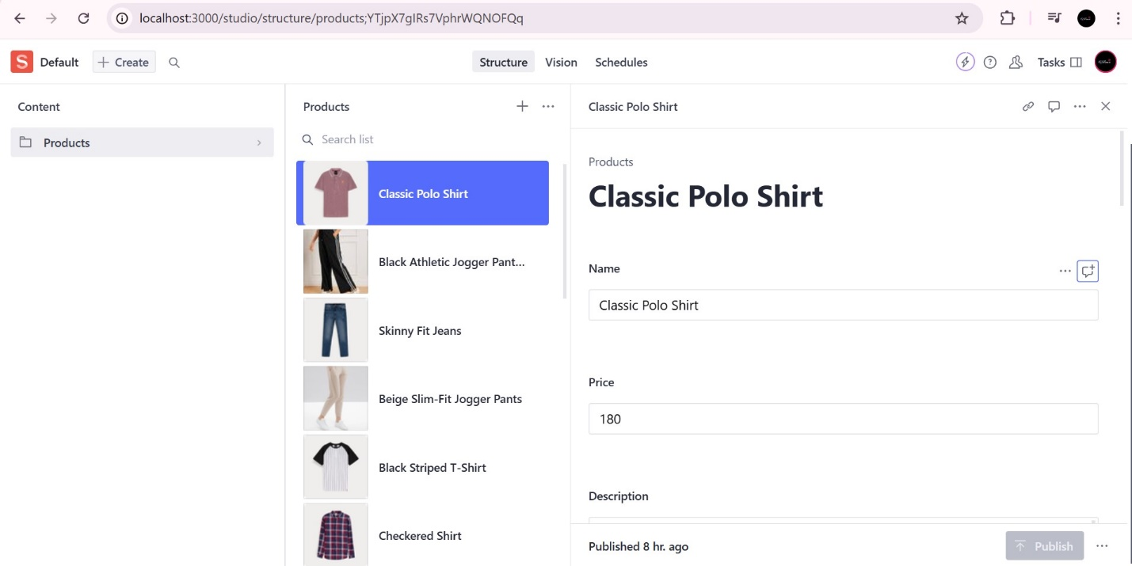

Next.js frontend displaying the integrated data.

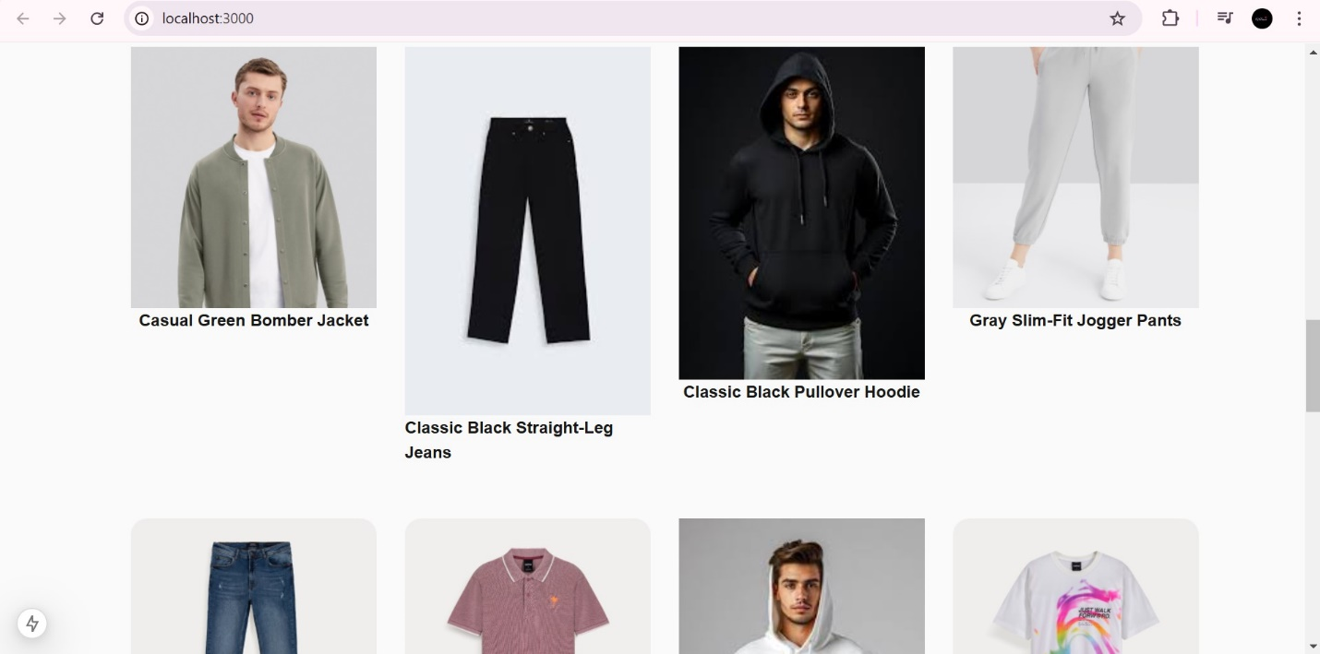

Conclusion
This task successfully covered:
- Setting up Next.js and Sanity CMS.
- Defining schemas for data organization.
- Migrating external API data into Sanity CMS.
- Verifying and displaying the data in both the CMS and frontend.
By following these steps, a functional backend was created for a marketplace project, demonstrating a practical application of modern web technologies.

